DWH – Task Bonus

Contents

1. Task 1 2

2. Task 2 4

3. Task 3 5

# Task 1

Анализ максимального, минимального и итогового объема продаж в отчете ниже:

* декабрь 2000 года;
* два канала: Интернет и прямые продажи;
* все страны.

Создайте запрос с использованием Oracle SQL for Aggregation и создайте тот же отчет (результаты экспорта в Excel).

select

(case when grouping (tm.calendar_month_desc)=1 then 'GRAND_TOTAL' else tm.calendar_month_desc end) as year_month,

(case when grouping (ch.channel_desc)=1 and grouping (tm.calendar_month_desc)=0 then 'Total by Channels' else ch.channel_desc end) as channel,

(case when grouping (cn.country_name)=1 and grouping (ch.channel_desc)=0 and grouping (tm.calendar_month_desc)=0 then ch.channel_desc||' Total by States' else cn.country_name end) as country,

to_char(round(max(sl.amount_sold)), '9,999,999') as max_sales$,

to_char(round(min(sl.amount_sold)), '9,999,999') as min_sales$,

to_char(round(sum(sl.amount_sold)), '9,999,999') as sales$

from sh.sales sl

join sh.times tm on sl.time_id = tm.time_id

join sh.channels ch on sl.channel_id = ch.channel_id

join sh.customers cs on sl.cust_id = cs.cust_id

join sh.countries cn on cs.country_id = cn.country_id

where calendar_month_desc = '2000-12' and channel_desc in ('Internet', 'Direct Sales')

group by rollup(tm.calendar_month_desc, ch.channel_desc, cn.country_name);

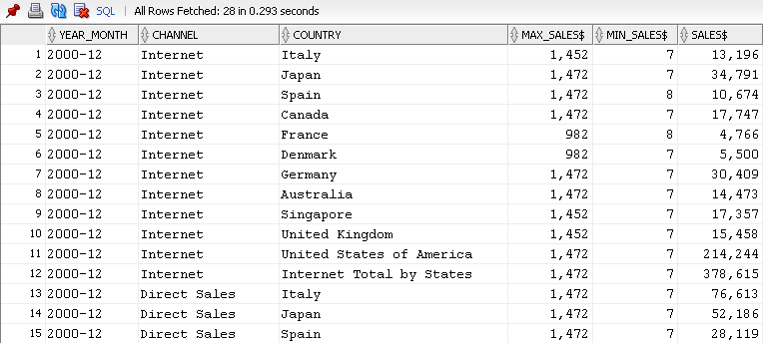

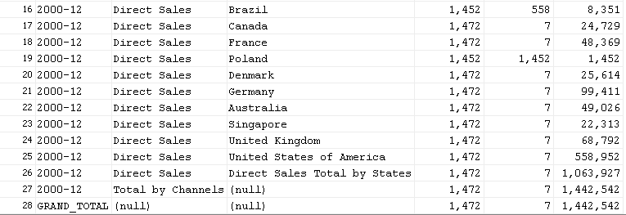

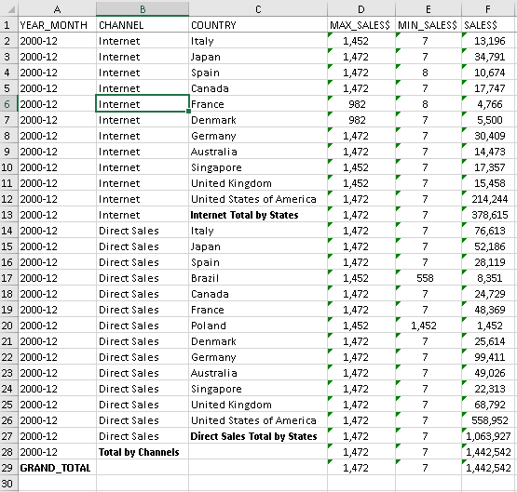

# Task 2

Напишите запрос для формирования отчёта о продажах в Азии всех продуктов из категории Photo за 2000 год по кварталам. Вычислите итоговые суммы (TOTAL и YEAR_SUM).

with dat as

(select pr.prod_name,

(case when tm.calendar_quarter_number=1 then sl.amount_sold else null end) as q1,

(case when tm.calendar_quarter_number=2 then sl.amount_sold else null end) as q2,

(case when tm.calendar_quarter_number=3 then sl.amount_sold else null end) as q3,

(case when tm.calendar_quarter_number=4 then sl.amount_sold else null end) as q4,

sl.amount_sold as year_sum

from sh.sales sl

join sh.times tm on sl.time_id = tm.time_id

join sh.customers cs on sl.cust_id = cs.cust_id

join sh.countries cn on cs.country_id = cn.country_id

join sh.products pr on sl.prod_id = pr.prod_id

where pr.prod_category_desc = 'Photo' and tm.calendar_year = '2000' and cn.country_region = 'Asia')

select nvl(prod_name,'Total') as product, sum(q1) as q1, sum(q2) as q2, sum(q3) as q3, sum(q4) as q4, sum (year_sum) as

from dat

group by rollup (prod_name);

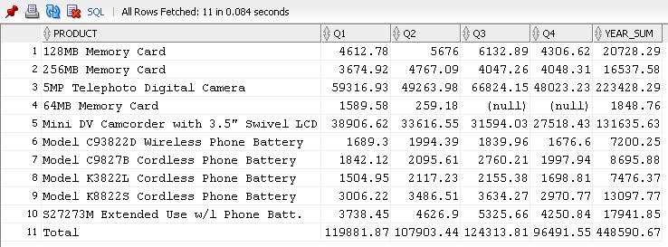

# Task 3

Напишите запрос для формирования отчёта о продажах в Азии всех продуктов из категории Photo за 2000 год по кварталам. Вычислите итоговые суммы (TOTAL и YEAR_SUM).

Я применила функцию Pivot к заданию 2, результат по данным тот же, производительность немного упала.

with dat as

(select pr.prod_name, sl.amount_sold, tm.calendar_quarter_number

from sh.sales sl

join sh.times tm on sl.time_id = tm.time_id

join sh.customers cs on sl.cust_id = cs.cust_id

join sh.countries cn on cs.country_id = cn.country_id

join sh.products pr on sl.prod_id = pr.prod_id

where pr.prod_category_desc = 'Photo' and tm.calendar_year = '2000' and cn.country_region = 'Asia'),

piv as

(select * from dat

pivot

(sum(dat.amount_sold)

for calendar_quarter_number

in(1 as q1, 2 as q2, 3 as q3, 4 as q4))

order by 1)

select (case when grouping (prod_name)=1 then 'Total' else prod_name end) as prod_name,

sum(q1) as q1, sum(q2) as q2, sum(q3) as q3, sum(q4) as q4, nvl(sum(q1),0)+nvl(sum(q2),0)+nvl(sum(q3),2)+nvl(sum(q4),0) as year_sum

from piv

group by rollup (prod_name)

;

